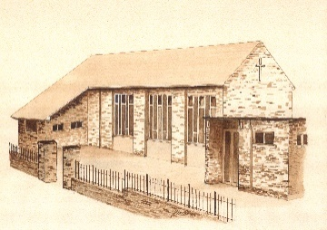
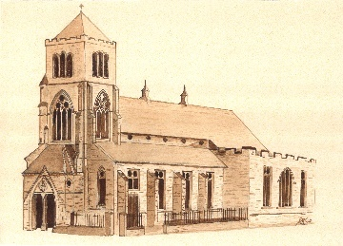
St Mary’s Parish, Halifax

Parish Census Form

PLEASE PRINT IN CAPITAL LETTERS
Full postal address of household including full postcode:

........................................................................................................................................................................................................... Postcode: ..........................

Home telephone number: ............................................................. Email address: .......................................................................................................................

* By giving your email address and telephone number, you consent to being contacted via this method.
DETAILS OF ALL ADULTS LIVING AT THE ABOVE ADDRESS
Household Member Ref. | First Name | Surname | Date  of  Birth | Mobile No. | Email Address | Occupation | Catholic (C)  OR  Non-Catholic (NC)
1A
2A
3A
4A
5A
* By giving your email address and telephone number, you consent to being contacted via this method.

DETAILS OF ALL PEOPLE UNDER THE AGE OF 18 LIVING AT THE ABOVE ADDRESS
Household Member  Ref: | First Name | Surname | Date  of  Birth | School/College | Sacraments Received  Please tick appropriate box(es) below
 |  |  |  |  | Baptism | Communion | Confirmation
1C
2C
3C
4C
5C

MASSES ATTENDED
Which Sunday Mass does each member of the household usually attend? Please indicate by putting the Household Member Ref. in the appropriate box below.
SUNDAY 9:30am | SUNDAY 11:00am | SUNDAY 6:00pm

METHOD OF FINANCIAL CONTRIBUTION TO THE PARISH
Please indicate, by ticking the appropriate box(es) below, the method by which your household contributes financially to the Parish:
Standing Order € Parish envelopes € Loose collection € Other € Please specify:
Standing Order is the most helpful way of donating to the Parish, as this means that the Parish can rely on receiving regular income throughout the year, rather than facing a reduction in income during holiday periods when the numbers attending Mass can be much reduced.
You may wish to think about switching your method of donating to the Parish. Standing Order forms are available at the back of the church.
Also, if you donate to the Parish by Standing Order or by using Parish envelopes and you are a tax payer, you could choose to gift aid your regular donation to the Parish. This would enable the Parish to claim a further 25% on top of your donation at no extra cost to you. Gift aid forms are available at the back of the church.

Thank you for completing the Census Form

Protecting your privacy: Your personal details are required for the specific purpose of processing the parish census and will not be shared outside of the parish. The information will be held on file and stored securely and only used for the purposes of the census and parish administration. The parish is part of the Diocese of Leeds and personal data is processed in accordance with the diocese’s Privacy Notice which is available at https://www.dioceseofleeds.org.uk/privacy-notice/ or from DPO@dioceseofleeds.org.uk
Registered Charity Number 249404

