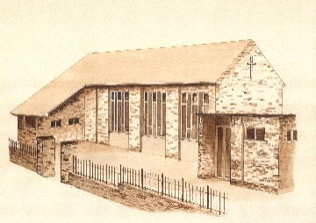
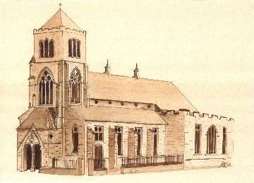
St Mary’s Parish, Halifax

Parish Census Form

PLEASE PRINT IN CAPITAL LETTERS
Full postal address of household including full postcode:

........................................................................................................................................................................................................... Postcode: ..........................

Home telephone number: ............................................................. Email address: .......................................................................................................................

* By giving your email address and telephone number, you consent to being contacted via this method.

DETAILS OF ALL ADULTS LIVING AT THE ABOVE ADDRESS
Household Member Ref. | First Name | Surname | Date  of  Birth | Mobile No. | Email Address | Occupation | Catholic (C)  OR  Non-Catholic (NC)
1A
2A
3A
4A
5A
* By giving your email address and telephone number, you consent to being contacted via this method.

DETAILS OF ALL PEOPLE UNDER THE AGE OF 18 LIVING AT THE ABOVE ADDRESS
Household Member  Ref: | First Name | Surname | Date  of  Birth | School/College | Sacraments Received  Please tick appropriate box(es) below
 |  |  |  |  | Baptism | Communion | Confirmation
1C

2C

3C

4C
5C

MASSES ATTENDED
Which Sunday Mass does each member of the household usually attend? Please indicate by putting the Household Member Ref. in the appropriate box below.
SUNDAY 9:30am | SUNDAY 11:00am | SUNDAY 6:00pm
Does anyone in the household require additional support to attend Mass due to any special needs and/or disabilities? Please tick appropriate box below.
No €
Yes € Please give details, including Household Member Ref.

AREAS OF PARISH LIFE
Please indicate, by putting the Household Member Ref. in the appropriate box(es), those areas of Parish Life that each household member is involved in already or would like to become involved in. Please note that training is available for these tasks, so if any household member would like to get involved, please don’t hesitate! Parishioners with experience will help.
LITURGY – Parish Worship | Already involved | Would like to be involved |  | HANDING ON OUR FAITH | Already involved | Would like to be involved
Sacristan |  |  |  | Baptism Preparation
Reader |  |  |  | Reconciliation
Eucharistic Minister |  |  |  | First Holy Communion
Altar Server |  |  |  | Confirmation
Choir |  |  |  | Children’s Liturgy
Playing a Musical Instrument |  |  |  | Faith Study/Prayer Group
Welcoming people at Mass

CARING FOR ONE ANOTHER | Already involved | Would like to be involved |  | BEHIND THE SCENES | Already involved | Would like to be involved
Visiting the Housebound |  |  |  | Fundraising
Using language skills |  |  |  | Organising social events
Bringing the elderly to Mass |  |  |  | Basic DIY (changing light bulbs, rubbish clearance etc)
Saint Vincent de Paul Society |  |  |  | Restoration, repairs and decoration
Bereavement Group |  |  |  | Cleaning the churches
Parish Ladies Guild |  |  |  | Flower arranging
 |  |  |  | Gardening/grounds maintenance
 |  |  |  | Administration

METHOD OF FINANCIAL CONTRIBUTION TO THE PARISH
Please indicate, by ticking the appropriate box(es) below, the method by which your household contributes financially to the Parish:
Parish envelopes €
Standing order €
Loose collection €
Other € Please specify:

Would you like to know more about Planned Giving? Yes € No €

ADDITIONAL INFORMATION
Please add below any other information which you consider relevant.

Thank you for completing the Census Form.

Protecting your privacy: Your personal details are required for the specific purpose of processing the parish census and will not be shared outside of the parish. The information will be held on file and stored securely and only used for the purposes of the census and parish administration. The parish is part of the Diocese of Leeds and personal data is processed in accordance with the diocese’s Privacy Notice which is available at https://www.dioceseofleeds.org.uk/privacy-notice/ or from DPO@dioceseofleeds.org.uk

Registered Charity Number 249404

